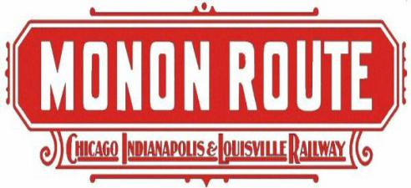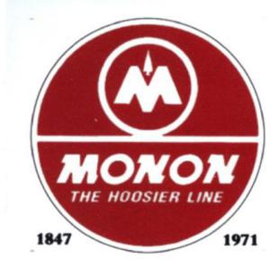

Monon Railroad Historical-Technical Society
E-News & Notes Vol. 2024-2
20 JUNE 2024
OUR 2024 ANNUAL CONVENTION will be the weekend of September 27-29. On Friday, the 27th, we will be in Delphi to walk on the now black topped former Monon mainline, including the high bridge, followed by a canal boat ride on the restored Wabash & Erie canal. We will also have access to their museum. There will be time to check in at the Brandywine Inn in Monticello before the 7:00 p.m dinner banquet which is at the Wabash & Erie Canal Park in Delphi. Remember to ask for the MONON discount when calling the Brandywine Inn and Suites 574-583-6333.

On Saturday a bus will take us from the Brandywine Inn to the Hoosier Valley Railroad Museum in North Judson and we will once again ride in Caboose 81532 and business car No. 2, The Lynne. The bus will then take us to the Whistle Stop Restaurant / Monon Connection Museum for dinner, and we will be able to tour the outstanding collection of railroad memorabilia that the late Dale Ward had collected.

The Annual Business Meeting will start at 9:00 a.m. on Sunday followed by the annual swap meet at 10:00 a.m. Both events will be back in Delphi at the Wabash & Eric Canal Park building. We are hoping for a surprise appearance while in Monon, but I can’t share the details at this time.

Remember the convention is a bargain at $99.00 if you can get your reservation in prior to August 15. A registration form is included. Hope you can make it to the convention!

Nominations for officers and four director positions are open and a nomination form is attached to this E-news & Notes for your convenience. Remember, these nomination forms are due by July 3, so get them in soon!
On July 4 WIBC in Indianapolis will be airing a program on the Monon Railroad. Mr. Kurt Darling of WIBC has spent countless hours researching and interviewing Monon fans and historians across the state. It will air live at 8:00 a.m. and again at 5:00 p.m., and there will be a podcast later, if you can not listen to it live. Go to 93.1 on your FM radio in the Indianapolis area or on the internet at https://wibc.com/ and click the blue button at the top right of the page. For a sample of the presentation, check our website at www.monon.org
We still need a member or two in Northern Indiana to represent us at local train shows in that area. We will cover the vendor cost and shipping cost. Working a train show is fun, and you will meet many interesting modelers and rail fans. If you can spare a day or two it would really help our society.

The Carmel Clay Historical Society will open their new three story museum later this fall. It is located adjacent to the former MONON mainline in downtown Carmel. Deb Gangstad is the Executive Director and they are looking for donations of Lionel models lettered for MONON to display in the museum. Any member wishing to donate a car or two please contact her at dgangstad@carmelclayhistory.org or give me a call. The large porcelain MONON sign that we donated a couple years ago (It was from the Indianapolis freight house) had been completely restored with neon lighting and will be displayed in the museum too. They are also restoring the old wooden Monon Carmel Depot. Of course any donations are tax deductible.

On December 11, 2023, Caboose 81532 and Business Car No. 2, aka The Lynne, made it to the Hoosier Valley Railroad Museum in North Judson, Indiana. The volunteers at Hoosier Valley have cleaned the inside of the Lynne and provided new furniture. She once again looks like a business car. They are also making the restoration of the Caboose 81532 a top priority. Todd Flanigan and Kevin Norman are pushing this ahead of their other restoration projects just for the members of the Monon Railroad Historical-Technical Society for our Annual Convention in September. MRHTS members attending the convention will be riding in the Lynne and the caboose. We need some volunteers to help with this restoration work. The work schedule is listed below. If you wish to help, please contact me at 812 583-5185 or jimcraig5185@gmail.com.

June 28 Sandblast
June 29 Prime exterior of caboose
July 27 Metalwork
August 10 Exterior paintwork
August 24 Windows/lettering
September 14 - Interior paintwork, clean and prep for HTS meet

The Company Store has a two NEW items for sale. We have the “Road On The Move” red T-shirts for sale and we still have some of the NEW Walthers Mainline RS-2 models in Monon paint scheme, both DC and DCC models. (see photos below) These items can be ordered through the company store at www.monon.org Other railroad items in stock are shown below as well.

The Company Store will be set up at the following train shows:
July 19 & 20 Friday and Saturday at the RPM modelers meet in St. Louis (Collinsville IL)
August 3 & 4 Saturday and Sunday at the Franklin IN NMRA train show.
November 23 Saturday for another NMRA train show in Danville, IN

Attachments from the Archives for this issue include:
- Two documents in this pdf. The first is Drawing D-99-49 for Standard Mile Post and Quarter Mile markings dated 01-07-49. The second is an October 8 1923 listing of Company track scales as well as Industry track scales.
- Another 1923 document shows Standard Signs for the Chicago Indianapolis & Louisville.
- A 1951 Shrine Special train move over the Monon.
- Timeline for the Monon starting in 1850!
- A copy of a 1987 Monon article from Indianapolis Monthly magazine

Jim C.

New Items from the Company Store

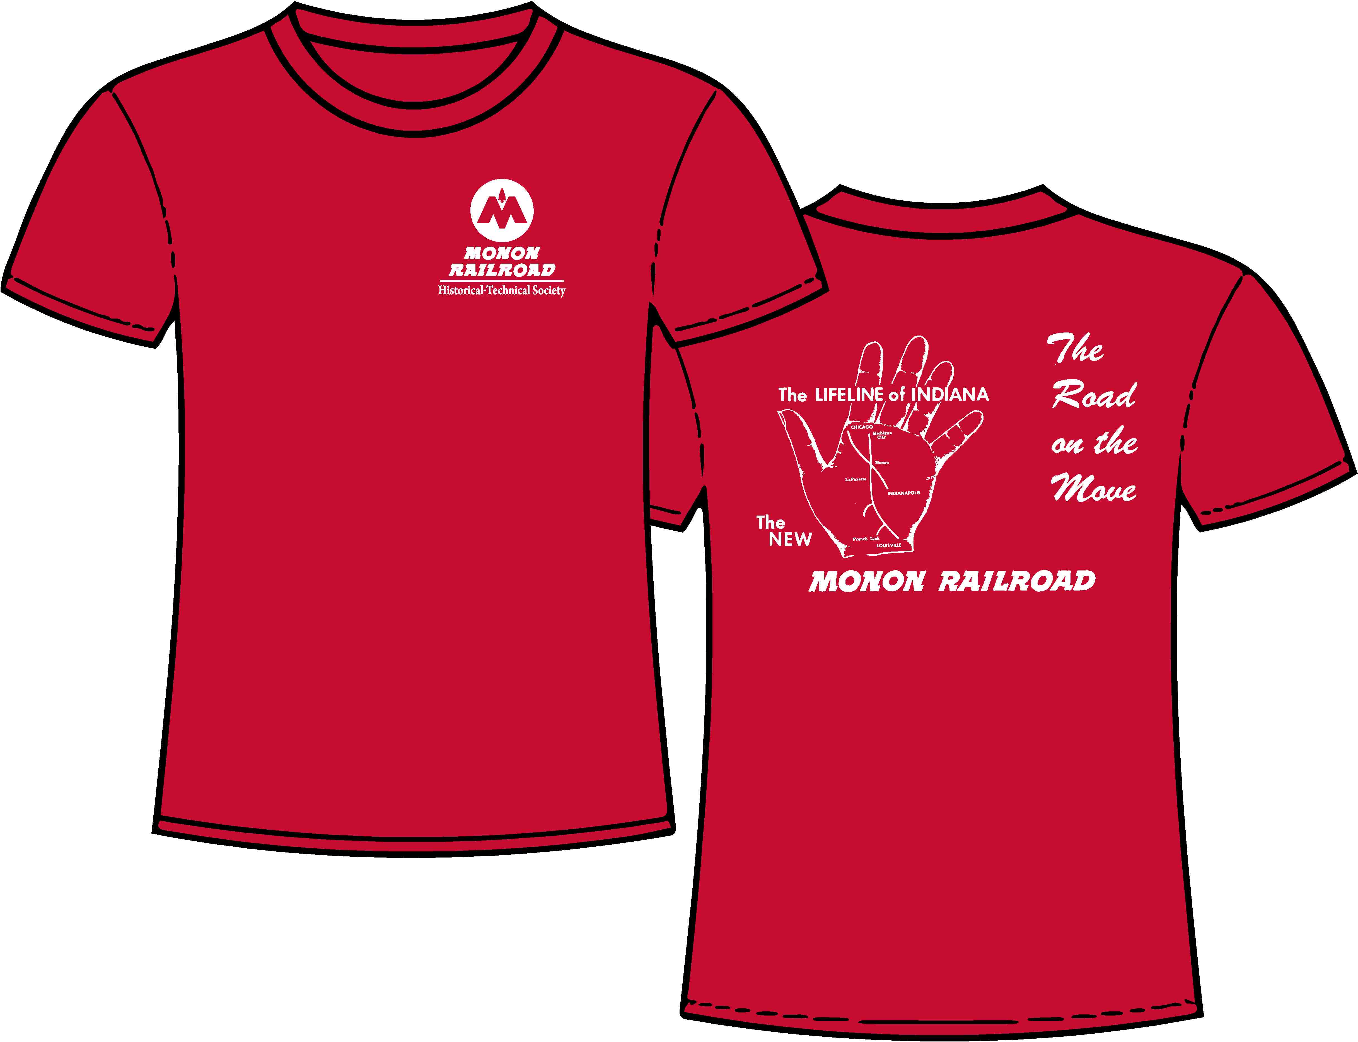

DC and DCC available - supply is limited
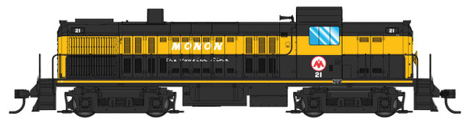

Shown below is some of the Company Store merchandise we still have for sale.
Go to www.monon.org and click on MRH-TS Online Store to place your order.

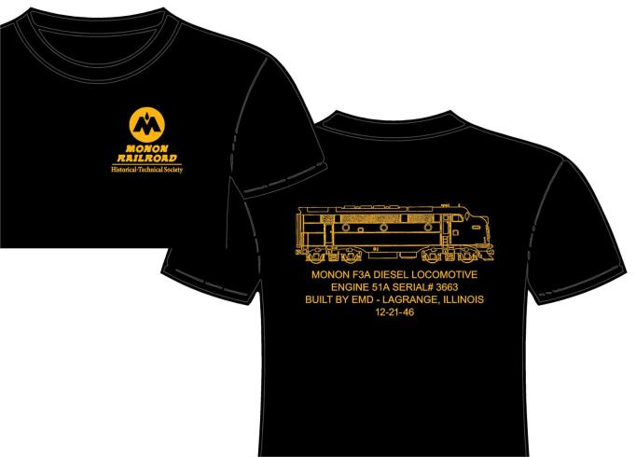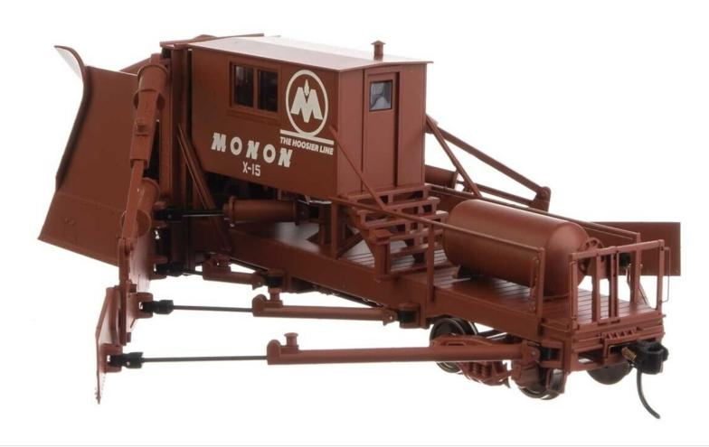

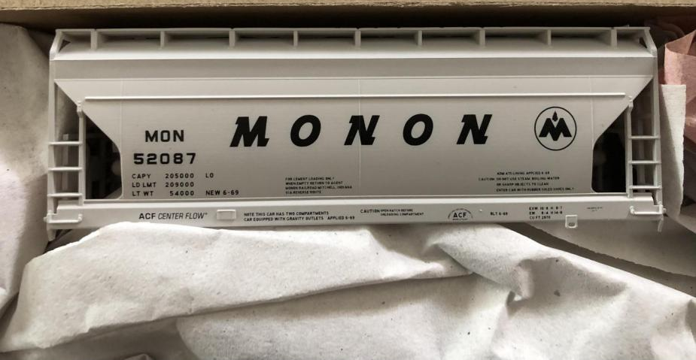

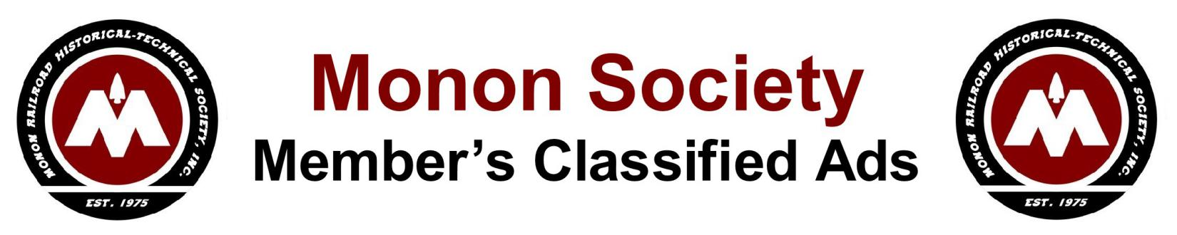
The Monon Society will list classified advertisements in our E-News & Notes as a courtesy to our members wanting to buy, sell or borrow Monon Railroad-related items. There is no charge and we plan to re-list it until we receive notice that the ad is no longer valid. Please submit a clear written description of the item you wish to buy, sell or borrow and your contact information. Then mail it to “Classified ads” at Monon Railroad Historical-Technical Society; P.O. Box 91; Salem, IN 47167.
(All personal classified ad business transactions shall take place directly between the buyer and seller with no implied involvement by the Monon Society or its representatives).

For Sale: Monon conductor’s hat badge. Hard to find item. $500.00. Please contact Richard Hebel at (812) 537-0150 if you are interested.

For Sale: Monon HO and N-scale Decals - 1945 - 1971 era. Please send a stamped, self-addressed envelope to Model Railroad Supply, 5660 N Quail Ln, Middletown, IN 47356 or contact mswitzer@switzertc.com.

For Sale: MONON steel switch lock and brass key - old, used. $160.00 Please contact Richard Hebel at 812 537-0150 if you are interested.

Wanted to Borrow: The key to unlock a Monon main line switch lock that I have. The lock is a Master Lock Co. #19 SBD and measures 1 3/8” thick, 3” wide and 4 1/2” bottom to top of hasp. The hasp is 9/16” in diameter. After unlocking the lock and getting the key number, it will be returned to the owner immediately. Please contact Donald Kaegebein, 455 Jenna Dr, Munster, IN 46321-4212 or call (219) 838-0649.

For Sale: 31800 Series Low Side Gondola Kits. If you attended the annual convention last September in Bedford, Andrew Weneger brought his quarry diorama for all to enjoy. On the quarry track was a Monon stone gon which Andrew has produced utiltizing 3D printing technology. He is offering these kits for sale.

Dayton Car Shops has produced a limited run of HO scale 3D-printed low-side gondola kits. These kits include everything needed to build a model except trucks, couplers, and decals. They are compatible with Kadee and similar couplers, and include an integral weight/stiffener for the modeler to embed in the underframe. They can be purchased for $35/kit plus $8 shipping and handling. Please send orders or inquiries to:
Andrew Wegener, 22 Oxford Avenue, Dayton, OH 45402 Or feel free to e-mail Dayton Car Shops at wegenerat@gmail.com, and stay tuned for future Monon releases.
History: The Monon (then CI&L) built 500 low-sided gondolas (31800-32299) in 1926 using second hand parts to haul cut limestone. These 40’ cars had steel frames and wood sides and floor to avoid damaging the cut stone. In 1942 the Monon still owned 497 of these cars, of which 30 had been equipped with AB style brakes (with plans to equip another 150 by 1943). Only 12 of these cars were listed to be in bad order. By June of 1946 the total number owned had dropped to 469, and by April of 1948 425 were rostered. Several of these lived long past their interchange days as MOW equipment, an example of which (renumbered 80608) can be found on George Elwood’s Fallen Flags photographed in Bedford in 1975.

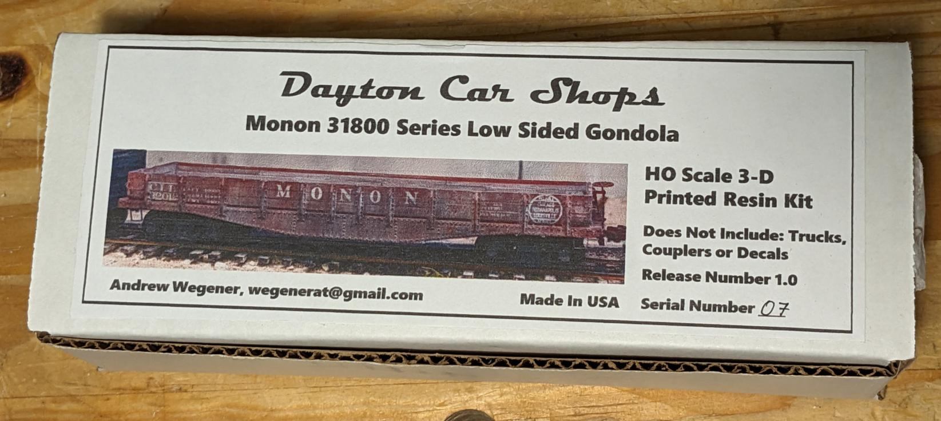

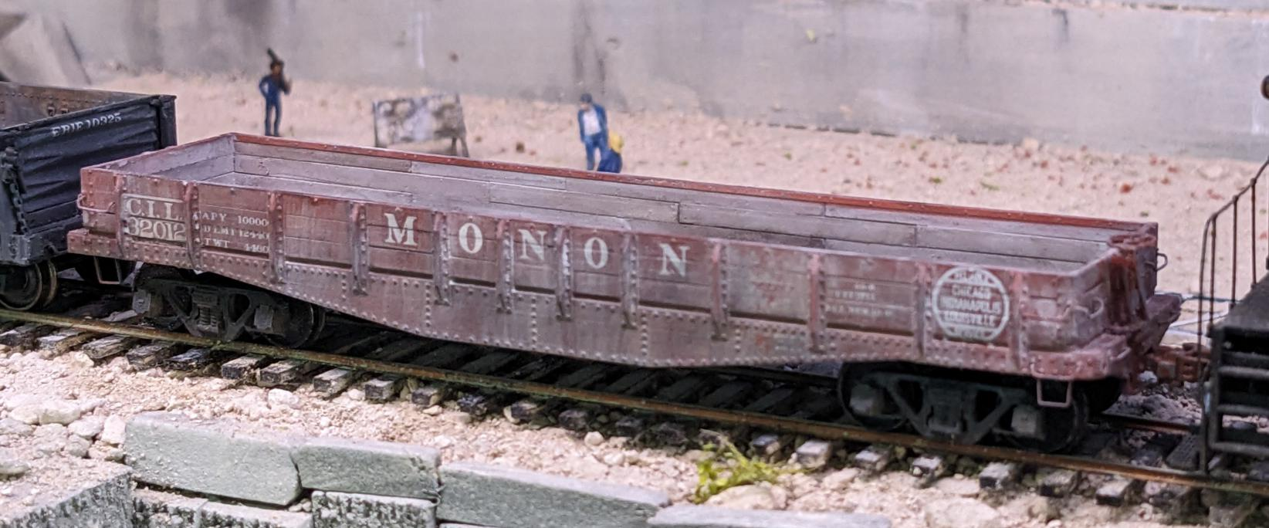

THE 49th MONON Annual Convention

2024 MRHTS Convention Registration Form
September 27th, 28th & 29th 2024
Delphi, Indiana

Name ___________________________________________________________

Phone # _____________________ Email Address ________________________

Registration:

Name of attendee __________________________________________________

Name of attendee __________________________________________________

The Convention cost BEFORE August 15th is $99/person.

The Convention cost AFTER August 15th is $119/person.

Please make your check out to MRHTS Convention and mail it along with this form to:

MRHTS
c/o Ron Simunic
6297 Viking Ridge RD
Bloomington, IN 47408

Contact Information:

Simunic22@att.net or (812) 322-7306

Vendor Tables:

If available, would you like to reserve vendor tables at the swap meet on Sunday, 9/29? They will be very limited and on a first come basis. If yes, enter the number of tables to reserve _______.

(For Internal Use Only: Postmarked date stamp _________ )

Monon Railroad Historical-Technical Society, Inc.
Membership Application Form

(Please check one) Membership Renewal ___ New Member Application ___

Annual Memberships Classes:
- Regular Membership One-Year ($50.00) _____
- Sustaining Membership One-Year ($60.00) _____
- Hoosier Membership One-Year ($75.00) _____
- Cecil J. Smith Membership One-Year ($100.00) _____
- Overseas Membership One-Year ($75.00) _____
- Bluegrass Membership One-Year ($250.00) _____
- Thoroughbred Membership One-Year ($500.00) _____

One-Time Membership Classes:
- James Brooks Lifetime Membership ($1,000.00) _____
- John W. Barriger III Corporate Membership ($2,500.00) _____
(Individuals may also purchase this class.)
Please complete the following:

Name _________________________________________
Address ________________________________________________ OR P.O. BOX # ______________
City __________________________________________ State _________ Zip Code __________-________
Phone # _____________/__________________ Cell# _____________/_______________________
E-mail Address ____________________________________________________________________________
Date of Birth (dd/mm/yyyy) ______________________________________
Are you a modeler? If so, what gauges or scales? ____________________________________
What other railroad related organizations do you belong to (NRHS, NMRA, etc.)? _______________________
__________________________________________________________________________________________
There are two ways to become a new member or renew your membership.
ONLINE: To renew your membership online go to www.mononmembership.store, click on the membership button, select the membership you would like and pay online. While you are there, browse the selection of Monon items now available for purchase.
POSTAL MAIL: Print and complete the above form and mail with your remittance to:
Monon Railroad Historical-Technical Society, Inc.
P O Box 91
Salem, IN 47167-0091
Monon Railroad Historical- Technical Society, Inc.
2024 - Nominations for Board of Directors & Officers

The Monon Railroad Historical–Technical Society, Inc. will hold its 2024 Annual Business Meeting in Delphi, , IN on Sunday, September 29, 2024. As required by Article VIII of the Society’s By-laws, the election of Officers and Directors is held during the Annual Business Meeting. This is your Opportunity to nominate candidates for eight Officer and Directors positions. Candidates must meet the qualifications for the office as listed in the Monon Society’s By-laws and must provide their written consent to be nominated for the office on the Board. This is accomplished by completing the Nomination Form on the reverse side of this notice or by submitting a nomination written (printed clearly) on plain paper or sending an e-mail.

The officers whose current one-year term will expire in 2024:
President – Jim Craig
Vice President - Ron Simunic
Secretary – Rick Dreistadt
Treasurer - Don Toon

The Directors whose two-year term will expire in 2024:
George Lortz
Dave Morrison
Jamie Stewart
Frank Van Bree

The Directors whose two-year term will not expire until 2025:
Mike Benham
John Butler
Joe Crnkovich
Steve Long

All Officers and Directors serve without compensation of any kind. The Board of Directors meets six times a year, weather permitting. Officers and Directors are required under the Monon Society’s By-laws to attend no less than four (4) Board of Directors Meetings each year. The Annual Meeting counts as a meeting, and credit is given for attendance at any meeting canceled due to inclement weather. Requirements for office set out in the Society’s By-laws Article IV Section 3 (paraphrased) as follows: (1) All candidates shall be members in good standing at least three (3) months prior to their nomination and election; (2) A candidate for Board President shall have served at least one (1) preceding year as a member of the Board of Directors.

If you would like to be a candidate or wish to nominate a candidate, please complete the nomination form below. Multiple nominations are permitted, but please submit only one nomination per form (or e-mail). Photo copies are acceptable or you may submit a handwritten nomination (printed clearly) on plain paper with a minimum of the candidate’s name, office nominated for and signature of the candidate. If you wish to nominate a candidate using e-mail, provide the information that appears on the nomination form below and submit it to John Butler, Nomination Committee Chairman at patchdevil@yahoo.com and request a receipt confirmation. The Nominations Committee must receive all nominations by Saturday, July 3, 2024.

If you are submitting the nomination form by standard postage mail, please mail it to: Monon Railroad Historical & Technical Society, Inc., Nomination Committee Chairman. P O Box 91, Salem, IN 47167.

Monon Railroad Historical-Technical Society, Inc. / Board of Directors Nomination Form
____________________________(Print Name) is hereby nominated for: _________________ (Office)
I, _________________________________ (Candidate’s signature) do hereby agree to serve if elected.

