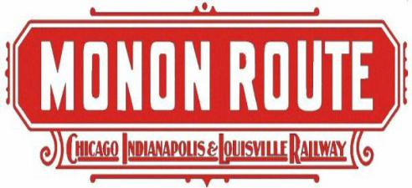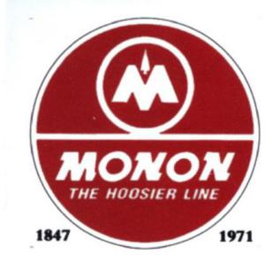

Monon Railroad Historical-Technical Society
E-News & Notes Vol. 2024-3
10 JULY 2024

MONON Caboose 81532 restoration work day is scheduled for this Saturday, July 13 at the Hoosier Valley RR Museum at 507 Mulberry Street, North Judson, Indiana. The caboose is located in the shop building across the street from the Depot. Long pants, work boots, gloves are required. If you can bring your own safety glasses and hearing protection, great. If not, these two items will be available. The museum volunteers have already made significant progress on the caboose (see photos below). Caboose 81532 has been completely sand blasted and primed. If any of our members could spare some time Saturday to pitch in on the restoration project, it would be greatly appreciated. HVRR volunteers are working hard to get the caboose restored for our annual convention, which is September 27 thru 29.

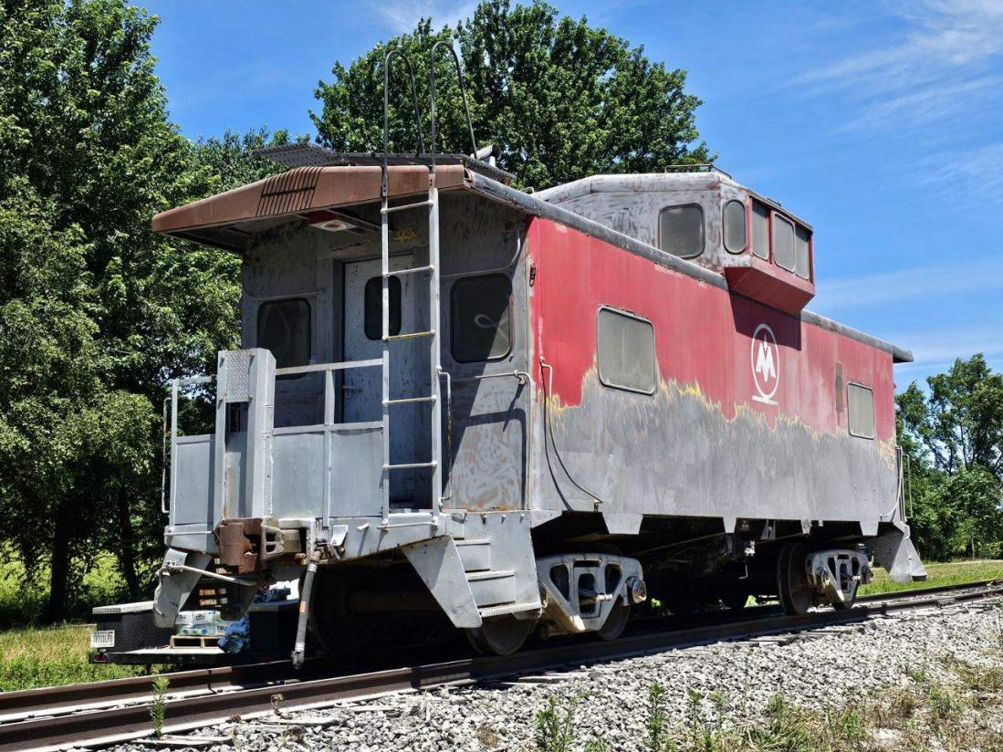
Old paint being removed from 81532 at Hoosier Valley Railroad Museum

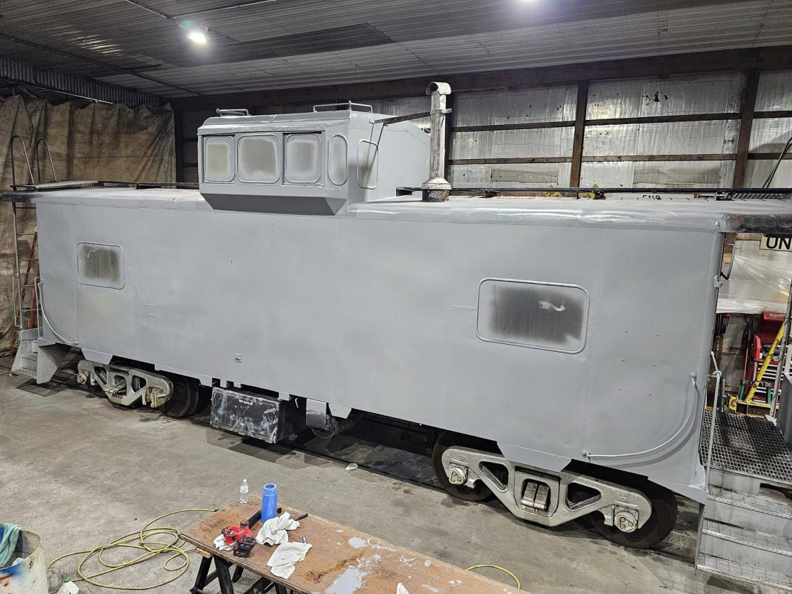
The primer has been applied and the next step is to work on the windows.

As a reminder, our annual convention is only $99.00 for those who register before August 15, after this date, the registration fee is $119.00 per person. Friday’s activities will be held in Delphi at the Wabash & Erie Canal Convention Center. Saturday we will head to North Judson Railroad Museum and later have dinner at the Monon Connection / Whistle Stop Restaurant. Sunday we will return to the Convention Center in Delphi for the Annual meeting followed by the swap meet. On page 3 is a convention registration form. Check our website for more information www.monon.org or contact any officer or director.

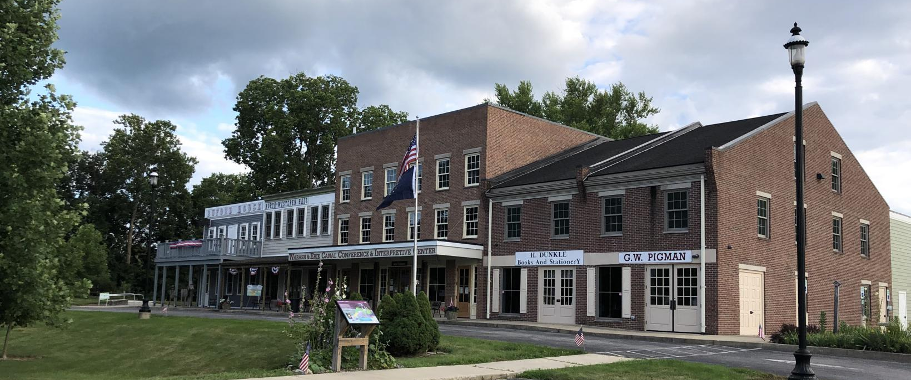
Convention Center in Delphi

Jim C.

THE 49th MONON Annual Convention

2024 MRHTS Convention Registration Form
September 27th, 28th & 29th 2024
Delphi, Indiana

Name ___________________________________________________________

Phone # _____________________ Email Address ________________________

Registration:

Name of attendee __________________________________________________

Name of attendee __________________________________________________

The Convention cost BEFORE August 15th is $99/person.

The Convention cost AFTER August 15th is $119/person.

Please make your check out to MRHTS Convention and mail it along with this form to:

MRHTS
c/o Ron Simunic
6297 Viking Ridge RD
Bloomington, IN 47408

Contact Information:

Simunic22@att.net or (812) 322-7306

Vendor Tables:

If available, would you like to reserve vendor tables at the swap meet on Sunday, 9/29? They will be very limited and on a first come basis. If yes, enter the number of tables to reserve _______.

(For Internal Use Only: Postmarked date stamp _________ )

